EWMA correlation: USDJPY and EURGBP
Method 06 / daily log returns / lambda = 0.94 / Alpari D1 full available history

Study setup
Logical pair: USDJPY , EURGBP
Broker symbols: USDJPY_i , EURGBP_i
Snapshot: 2026-11-03_majors_alpari_D1
Timeframe: D1
Matched return window: 1999-01-06 to 2026-11-02 (UTC bar dates)
Matched return count n: 7181
Dropped unfinished last bar dated 2026-11-03 UTC after a tick-volume check against the prior complete day.
Lambda: 0.94 (today weight 0.06)
Burn-in ignored in path summaries and chart: first 60 updates
Mean adjustment: each leg demeaned by its mean on the matched rows
Seeds: c_0 = v_x,0 = v_y,0 = 0
Complete matched rows (Excel): USDJPY-EURGBP_EWMA_D1.xlsx
Complete matched rows (HTML table): USDJPY-EURGBP_EWMA_D1_data.html

Method carried forward
EWMA correlation updates covariance and variances of mean-adjusted daily log returns of close, ln(close_t / close_t-1), with lambda = 0.94 (6% weight on today's product or square, 94% on yesterday's EWMA state). Quotes are not inverted. Each leg is demeaned by its mean on the matched rows; that mean uses the full sample, so the rho path is a full-sample description, not a live filter. Seeds start at zero. Path summaries and the chart ignore the first 60 updates so the zero seed has faded. The headline is rho on the last day. rho is symmetric under swap of the two symbols. A high |rho| does not prove cause, lead-lag, or a trading signal. Today's return sits inside today's rho, so the estimate can only inform a later decision. Same-sample Pearson r is a side check only.

Results
Latest EWMA rho: 0.124155
Post-burn-in path (n=7121): mean=-0.108939, median=-0.111994, min=-0.778783, max=0.694128, std=0.234409
Share of post-burn-in days with |rho| >= 0.4: 11.87%; |rho| >= 0.7: 0.41%
Same-sample Pearson r: -0.127992
Latest rho minus r: 0.252147

Conclusion
Over 7181 matched daily log-return rows for USDJPY and EURGBP (broker quote directions unchanged), latest EWMA rho with lambda=0.94 is 0.1242 (positive, weak recent linear link in this sample). After a 60-day burn-in, path mean is -0.1089, std is 0.2344, and the range is [-0.7788, 0.6941]. Same-sample Pearson r is -0.1280 (latest rho minus r = 0.2521). This does not establish cause, lead-lag, or a lasting trading rule.

Charts
Daily closes

Daily log returns
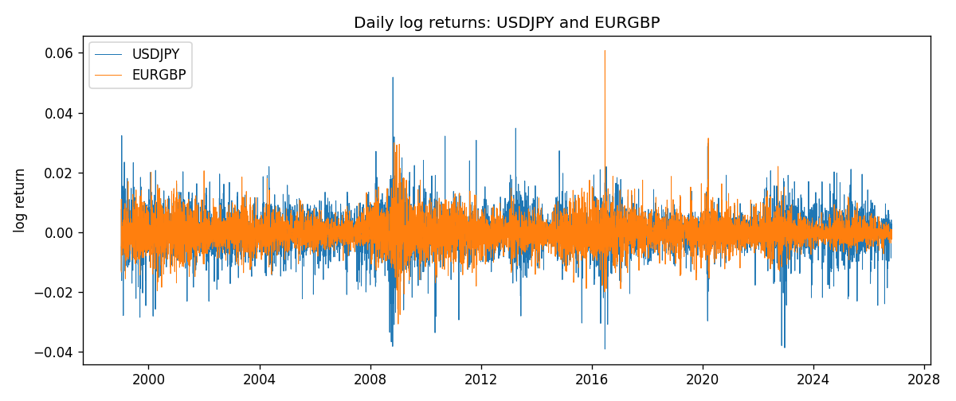
EWMA rho path with Pearson r reference
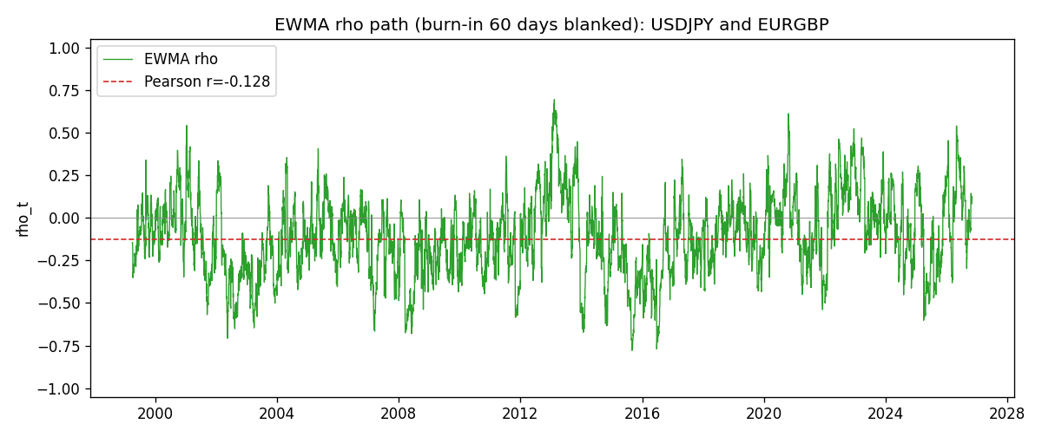

Data report
Every matched row that entered the EWMA recursion is stored in the sibling Excel workbook named USDJPY-EURGBP_EWMA_D1.xlsx. That file is the complete data archive for redrawing charts. Embedding all rows as a Word table is impractical at this length; the Word file holds the column list, column summaries, and the first and last 15 matched rows.
Columns: time, USDJPY_open, EURGBP_open, USDJPY_high, EURGBP_high, USDJPY_low, EURGBP_low, USDJPY_close, EURGBP_close, USDJPY_tick_volume, EURGBP_tick_volume, USDJPY_spread, EURGBP_spread, USDJPY_real_volume, EURGBP_real_volume, USDJPY_log_return, EURGBP_log_return, USDJPY_x_demeaned, EURGBP_y_demeaned, c_t, v_x, v_y, rho_t
Column summaries (matched calculation rows)
column | count | mean | std | min | 25% | 50% | 75% | max
USDJPY_open | 7181 | 113.80773 | 19.228846 | 75.693 | 104.38 | 110.98 | 120.71 | 163.824
EURGBP_open | 7181 | 0.78701429 | 0.09663819 | 0.5734 | 0.6877 | 0.83392 | 0.86523 | 0.9769
USDJPY_high | 7181 | 114.30513 | 19.290536 | 76.001 | 104.865 | 111.439 | 121.27 | 163.978
EURGBP_high | 7181 | 0.79009197 | 0.09701345 | 0.5789 | 0.6897 | 0.83701 | 0.8681 | 0.9799
USDJPY_low | 7181 | 113.28458 | 19.156841 | 75.402 | 103.87 | 110.53 | 120.172 | 163.628
EURGBP_low | 7181 | 0.78431381 | 0.09645598 | 0.5682 | 0.6857 | 0.83166 | 0.86287 | 0.9661
USDJPY_close | 7181 | 113.82069 | 19.244339 | 75.811 | 104.38 | 111.015 | 120.695 | 163.851
EURGBP_close | 7181 | 0.78705735 | 0.09663932 | 0.5735 | 0.6878 | 0.83401 | 0.86539 | 0.977
USDJPY_tick_volume | 7181 | 106398.86 | 179473.16 | 149 | 9958 | 53207 | 92916 | 1803508
EURGBP_tick_volume | 7181 | 87156.048 | 145513.65 | 154 | 6593 | 44384 | 81451 | 1424684
USDJPY_spread | 7181 | 20.250104 | 17.60648 | 0 | 6 | 11 | 30 | 50
EURGBP_spread | 7181 | 21.316669 | 19.115948 | 0 | 4 | 13 | 40 | 50
USDJPY_real_volume | 7181 | 3.4800425e+10 | 1.6097887e+11 | 0 | 0 | 0 | 0 | 3.8834203e+12
EURGBP_real_volume | 7181 | 2.788005e+10 | 1.3523257e+11 | 0 | 0 | 0 | 0 | 3.5726265e+12
USDJPY_log_return | 7181 | 4.847e-05 | 0.00620794 | -0.03908203 | -0.00320533 | 0.00011473 | 0.00340924 | 0.05184024
EURGBP_log_return | 7181 | 2.133e-05 | 0.00487349 | -0.03067367 | -0.00262366 | -0.00010035 | 0.00255918 | 0.06075387
USDJPY_x_demeaned | 7181 | 0 | 0.00620794 | -0.0391305 | -0.0032538 | 6.626e-05 | 0.00336078 | 0.05179177
EURGBP_y_demeaned | 7181 | -0 | 0.00487349 | -0.030695 | -0.00264498 | -0.00012167 | 0.00253786 | 0.06073254
c_t | 7181 | -3.87e-06 | 1.089e-05 | -0.00016 | -6.58e-06 | -2.19e-06 | 6.8e-07 | 4.538e-05
v_x | 7181 | 3.85e-05 | 3.193e-05 | 3.39e-06 | 1.905e-05 | 3.095e-05 | 4.775e-05 | 0.00041229
v_y | 7181 | 2.374e-05 | 2.337e-05 | 1.89e-06 | 1.049e-05 | 1.824e-05 | 3.016e-05 | 0.00029342
rho_t | 7181 | -0.1103128 | 0.23445527 | -1 | -0.26905903 | -0.11357181 | 0.03886735 | 0.69412791
First 15 matched rows (selected columns)
time | USDJPY_close | EURGBP_close | USDJPY_log_return | EURGBP_log_return | USDJPY_x_demeaned | EURGBP_y_demeaned | c_t | v_x | v_y | rho_t
1999-01-06 | 112.77 | 0.7019 | 0.0075660159 | -0.013303338 | 0.0075175482 | -0.013324664 | -6.010128e-06 | 3.3908118e-06 | 1.06528e-05 | -1
1999-01-07 | 111.33 | 0.7097 | -0.012851583 | 0.011051402 | -0.01290005 | 0.011030076 | -1.4186833e-05 | 1.3172041e-05 | 1.7313386e-05 | -0.93943751
1999-01-08 | 110.8 | 0.7062 | -0.0047719894 | -0.004943862 | -0.0048204572 | -0.0049651876 | -1.1899554e-05 | 1.3775927e-05 | 1.7753769e-05 | -0.76089547
1999-01-11 | 109.02 | 0.7053 | -0.016195423 | -0.0012752393 | -0.01624389 | -0.0012965648 | -9.9219055e-06 | 2.878121e-05 | 1.6789407e-05 | -0.45135981
1999-01-12 | 112.6 | 0.7077 | 0.032310364 | 0.0033970309 | 0.032261896 | 0.0033757053 | -2.7921919e-06 | 8.9504135e-05 | 1.6465766e-05 | -0.072733208
1999-01-13 | 113.52 | 0.708 | 0.0081373171 | 0.00042381861 | 0.0080888494 | 0.00040249305 | -2.429318e-06 | 8.8059656e-05 | 1.548754e-05 | -0.065781634
1999-01-14 | 113.52 | 0.7066 | 0 | -0.0019793588 | -4.846773e-05 | -0.0020006843 | -2.2777408e-06 | 8.2776217e-05 | 1.4798452e-05 | -0.065079375
1999-01-15 | 114.15 | 0.7012 | 0.0055343401 | -0.0076715819 | 0.0054858724 | -0.0076929074 | -4.6732149e-06 | 7.9615332e-05 | 1.7461394e-05 | -0.12533661
1999-01-18 | 114.16 | 0.7017 | 8.7600193e-05 | 0.00071280921 | 3.9132463e-05 | 0.00069148365 | -4.3911984e-06 | 7.4838504e-05 | 1.64424e-05 | -0.12518086
1999-01-19 | 113.52 | 0.7007 | -0.0056219403 | -0.0014261269 | -0.005670408 | -0.0014474524 | -3.6352678e-06 | 7.2277405e-05 | 1.5581563e-05 | -0.10832523
1999-01-20 | 112.91 | 0.7021 | -0.0053879917 | 0.0019960086 | -0.0054364594 | 0.0019746831 | -4.0612688e-06 | 6.9714066e-05 | 1.4880631e-05 | -0.12609296
1999-01-21 | 113.87 | 0.7016 | 0.0084664056 | -0.00071240297 | 0.0084179379 | -0.00073372852 | -4.1881815e-06 | 6.9782923e-05 | 1.4020095e-05 | -0.13389842
1999-01-22 | 114.56 | 0.7004 | 0.0060412564 | -0.0017118406 | 0.0059927887 | -0.0017331662 | -4.5600805e-06 | 6.7750759e-05 | 1.3359121e-05 | -0.15157462
1999-01-25 | 113.72 | 0.6966 | -0.0073594164 | -0.0054402425 | -0.0074078842 | -0.005461568 | -1.8589559e-06 | 6.6978318e-05 | 1.4347297e-05 | -0.059967635
1999-01-26 | 113.86 | 0.6962 | 0.0012303367 | -0.00057438255 | 0.001181869 | -0.00059570811 | -1.7896615e-06 | 6.3043428e-05 | 1.3507752e-05 | -0.061328091
Last 15 matched rows (selected columns)
time | USDJPY_close | EURGBP_close | USDJPY_log_return | EURGBP_log_return | USDJPY_x_demeaned | EURGBP_y_demeaned | c_t | v_x | v_y | rho_t
2026-10-13 | 158.305 | 0.84458 | -0.0018932826 | 0.00020130374 | -0.0019417503 | 0.00017997818 | -6.2673254e-07 | 1.977001e-05 | 2.6744037e-06 | -0.086191674
2026-10-14 | 158.317 | 0.84553 | 7.5800166e-05 | 0.0011241873 | 2.7332435e-05 | 0.0011028617 | -5.8731995e-07 | 1.8583854e-05 | 2.5869177e-06 | -0.084706269
2026-10-15 | 158.024 | 0.84479 | -0.0018524319 | -0.00087557391 | -0.0019008997 | -0.00089689947 | -4.497858e-07 | 1.7685628e-05 | 2.4799684e-06 | -0.067916051
2026-10-16 | 157.964 | 0.84307 | -0.00037976126 | -0.0020380844 | -0.00042822899 | -0.00205941 | -3.6988471e-07 | 1.6635493e-05 | 2.5856405e-06 | -0.0563981
2026-10-19 | 158.517 | 0.84259 | 0.0034946841 | -0.00056950988 | 0.0034462164 | -0.00059083544 | -4.6986043e-07 | 1.6349948e-05 | 2.4514472e-06 | -0.07421632
2026-10-20 | 158.16 | 0.83957 | -0.0022546642 | -0.0035906254 | -0.002303132 | -0.003611951 | 5.7459177e-08 | 1.5687216e-05 | 3.0871318e-06 | 0.0082567451
2026-10-21 | 158.108 | 0.83839 | -0.00032883504 | -0.00140647 | -0.00037730277 | -0.0014277956 | 8.6334299e-08 | 1.4754525e-05 | 3.0242199e-06 | 0.01292451
2026-10-22 | 156.755 | 0.83682 | -0.0085942669 | -0.0018743924 | -0.0086427346 | -0.001895718 | 1.0642055e-06 | 1.8351065e-05 | 3.0583915e-06 | 0.14205232
2026-10-23 | 156.81 | 0.83751 | 0.00035080446 | 0.00082421033 | 0.00030233673 | 0.00080288477 | 1.0149176e-06 | 1.7255485e-05 | 2.9135654e-06 | 0.14313796
2026-10-26 | 157.458 | 0.83762 | 0.0041238746 | 0.00013133309 | 0.0040754069 | 0.00011000753 | 9.8092212e-07 | 1.7216693e-05 | 2.7394776e-06 | 0.14283209
2026-10-27 | 157.894 | 0.83595 | 0.0027651658 | -0.0019957343 | 0.002716698 | -0.0020170599 | 5.9328223e-07 | 1.6626518e-05 | 2.8192208e-06 | 0.086655502
2026-10-28 | 157.743 | 0.83651 | -0.00095679538 | 0.00066967224 | -0.0010052631 | 0.00064834669 | 5.1857976e-07 | 1.568956e-05 | 2.6752888e-06 | 0.080043274
2026-10-29 | 157.683 | 0.83553 | -0.00038043789 | -0.0011722209 | -0.00042890562 | -0.0011935465 | 5.181801e-07 | 1.4759224e-05 | 2.6002446e-06 | 0.083645361
2026-10-30 | 157.516 | 0.83351 | -0.0010596481 | -0.0024205543 | -0.0011081159 | -0.0024418799 | 6.4944244e-07 | 1.3947346e-05 | 2.8019966e-06 | 0.10388697
2026-11-02 | 157.933 | 0.83426 | 0.0026438521 | 0.00089940465 | 0.0025953843 | 0.0008780791 | 7.4721306e-07 | 1.3514666e-05 | 2.6801382e-06 | 0.12415471

